LKM - accenture
Cloud formation

With AWS CloudFormation we can easily create and manage a collection of related AWS resources, we can provision and update them in an orderly and predictable fashion.
CloudFormation allows you to use a simple json file to model and provision all the infrastructure resources needed for your applications across all regions and accounts.
AWS CloudFormation is available at no additional charge, and you pay only for the AWS resources needed to run your applications.
Template:
A template is the JSON file that describes your setup (what resources to be created). It can be big or small and has to adhere to the AWSTemplateFormat you define. You define this for the initial setup, and then you can make changes to it for further updates.
Example :
"AWSTemplateFormatVersion”:"2010-09-09“
"Description": “This is an example template",
Stack:
A stack is the implementation of your template. When you upload your stack to AWS it will turn that into the infrastructure you requested. This can range from a single EC2 instance to a complex system of hundreds of instances and using almost every AWS service.
Resource:
Resources are the various services you define in your json template. This can be anything from an EC2 instance to a SQS queue, and for each resource you define several properties. You can find a complete list of resources and their properties in the AWS Resource Types reference.
Example:
"Resources": {
"IPAddress”: {
"Type”:"AWS::EC2::EIP",
"Properties”: {
"InstanceId”: {
"Ref”:"Webserver"
},
"Domain”:"vpc"
}
},

Parameters:
Parameters option enables us to pass values into our template at the time of cloud formation stack creation. So, in this way, we can create customized stacks for each deployment
Example: Passing the key-pair at the time of stack creation.
Conditions:
Conditions that control whether certain resources are created or whether certain resource properties are assigned a value during stack creation or update.
For example, you could conditionally create a resource that depends on whether the stack is for a production or dev or test environment.
Outputs:
Describes the values that are returned whenever you view your cloud formation stack's properties.
For example, you can declare an output for an S3 bucket name and then call the aws cloudformation describe-stacks (AWS CLI command) to view the name.

Example Template:
{
"AWSTemplateFormatVersion”:"version date",
"Description”:"JSON string",
"Parameters”: {
set of parameters (Values to pass to your template at runtime)
},
"Conditions”: {
set of conditions (Conditions that control whether certain resources are created or whether certain resource properties are assigned a value during stack creation or update)
},
"Resources”: {
set of resources (Specifies the stack resources and their properties, such as an Amazon Elastic Compute Cloud instance )
},
"Outputs”: {
set of outputs (Describes the values that are returned whenever you view your stack's properties)
}
}

Let’s take a scenario where you want to create an EC2 instance. You can make use of the same template to create other EC2 instance. Like you will be creating three similar environments for DEV, TEST and UAT. You no need to do it manually through console, just deploy the code.
Creating EC2 Instance:
{
"AWSTemplateFormatVersion": "2010-09-09",
"Description": "Launch an Instance",
"Parameters": {
"KeyName": {
"Description": "Name of an existing key pair",
"Type": "AWS::EC2::KeyPair::KeyName",
"ConstraintDescription": "must be the name of existing key pair"
}
},
"Resources”: {
"EC2Instnce”: {
"Type”:"AWS::EC2::Instance",
"Properties”: {
"ImageId”:"ami-6b8cef13",
"InstanceType”:"t2.micro",
"SecurityGroups”:[
{
"Ref”:"WebSecurityGroup"
}
],
"KeyName”: {"Ref”:"KeyName" },
"Tags”:[
{
"Key”:"Name",
"Value": "Web1"
}
]
}
},
"WebSecurityGroup”: {
"Type”:"AWS::EC2::SecurityGroup",
"Properties”: {
"GroupDescription”:"Enable HTTP nad SSH Access",
"SecurityGroupIngress”:[
{
"IpProtocol”:"tcp",
"FromPort”:"80",
"ToPort”:"80",
"CidrIp”:"0.0.0.0/0"
},
{
"IpProtocol”:"tcp",
"FromPort”:"22",
"ToPort”:"22",
"CidrIp”:"0.0.0.0/0"
}
]
}
}
}
}

After writing the template, let’s upload it in the stack.
Go to CloudFormation and create a stack
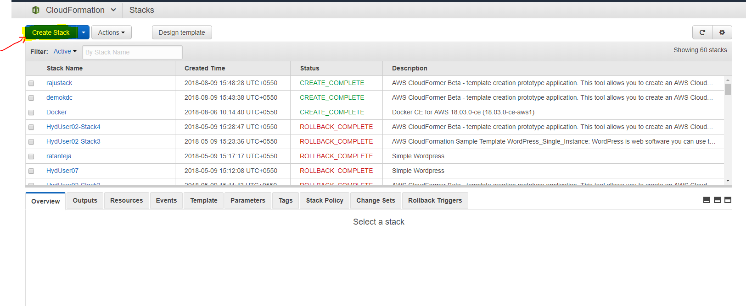

Upload the json formatted template and click next.
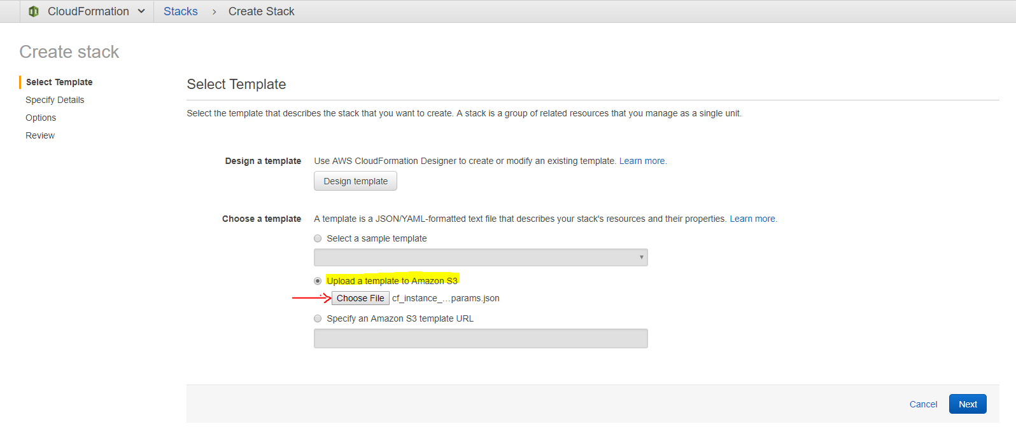

Name your stack and click next.
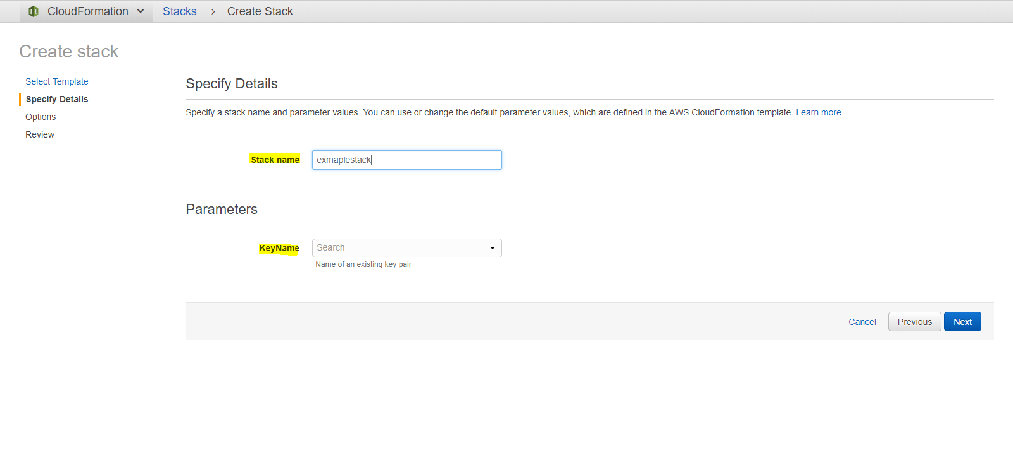
Give tag names and click next
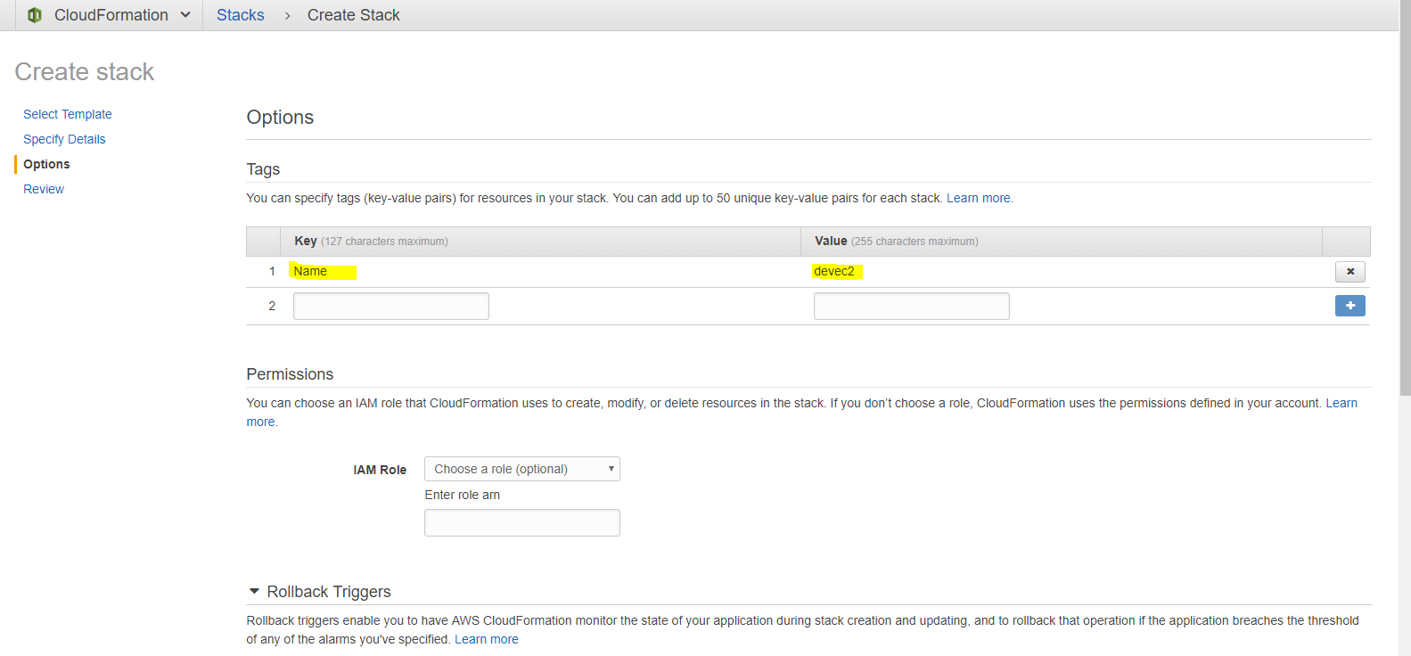

Review the stack and create the stack
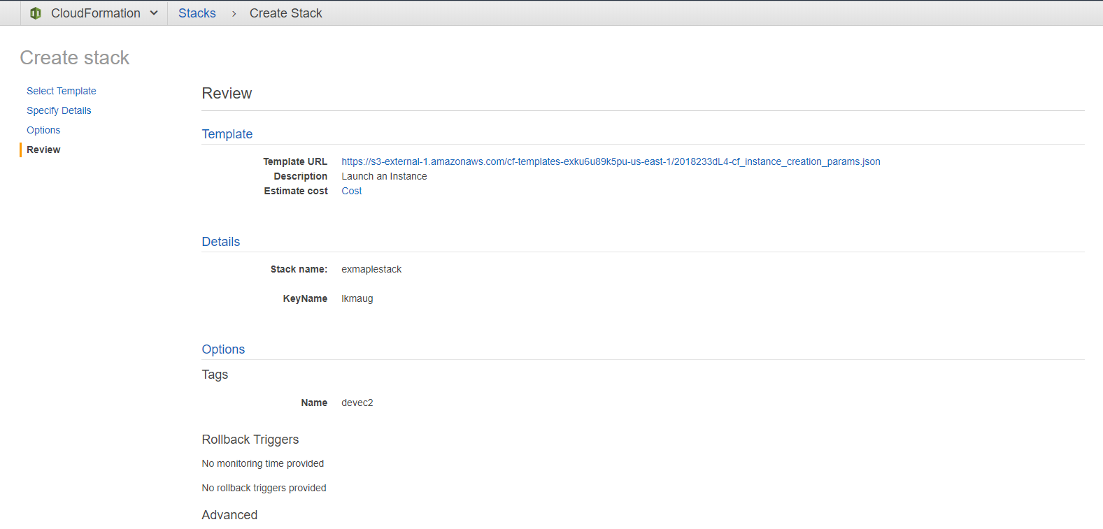
Your stack and resources are created mentioned in the templated. The stack rolls back if the resources mentioned in the template not found.
Ex: Keypair for ec2 instances
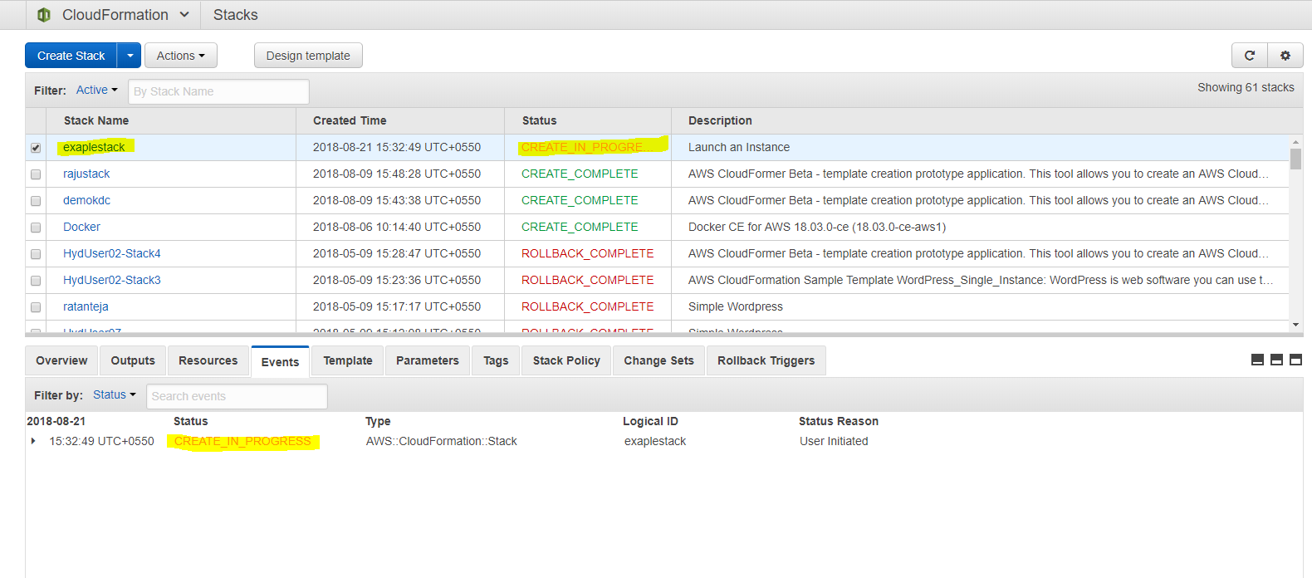

Hope you all uncovering the document accessible and useful.
If you have any demanding question which is mentioned in the document, please feel free to contact us.
Happy Learning LKM

